LaNier, Robert

CSC-314

Lab0xFF-Screenshots

Features implemented:

1. Created level file
2. Space bar pauses game
3. Attempted – Assemblipede grows by one body segment
4. Don’t allow Assemblipede to move off the level map
5. At start of game, don’t allow tail to “shrink”
6. Assemblipede dies (game over)
7. Did not complete – Show a “score”
8. Did not complete – Portal

This was a very challenging, but entertaining final exam. I’ve not had anything similar to it in the past. There were some frustrating parts (trying to figure out how to grow the tail), but overall I felt good about what I learned from this lab, but from the class overall. At first I thought everything was going over my head, but by doing this lab I had to acknowledge that I have learn quite a lot and I’m proud to say that I have a good understanding of the concept of assembly and writing simple programs.

Creating the level

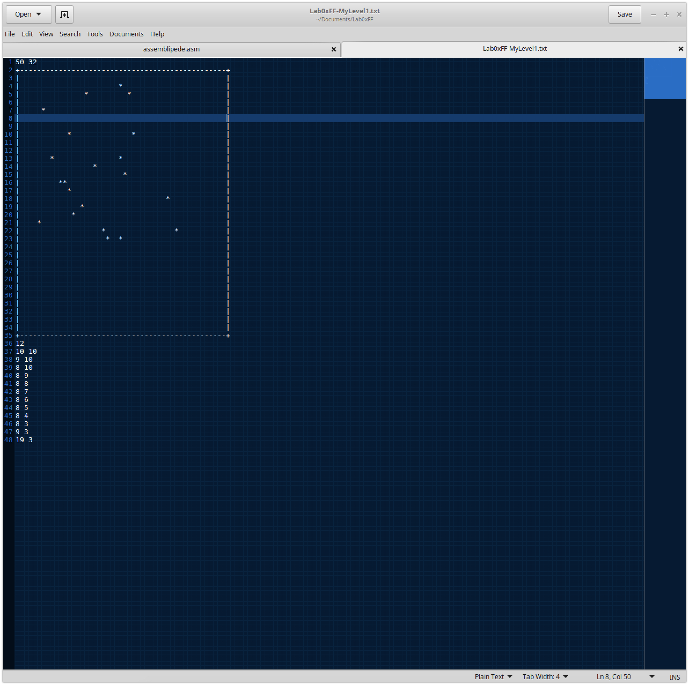

Testing the level

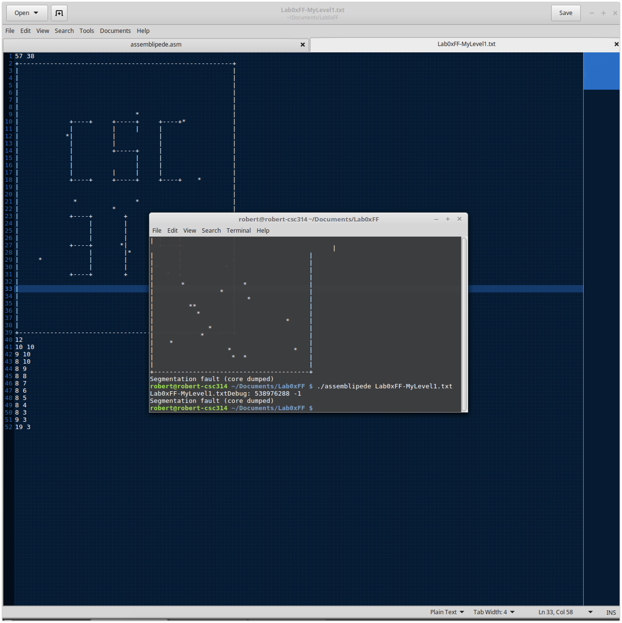

Trying to debug why my level won’t start

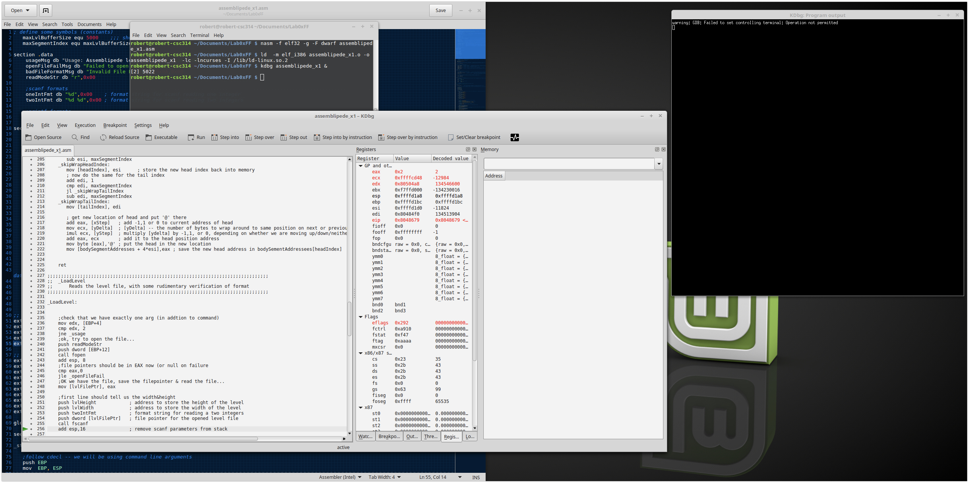

Testing and Debugging my first version of the programming

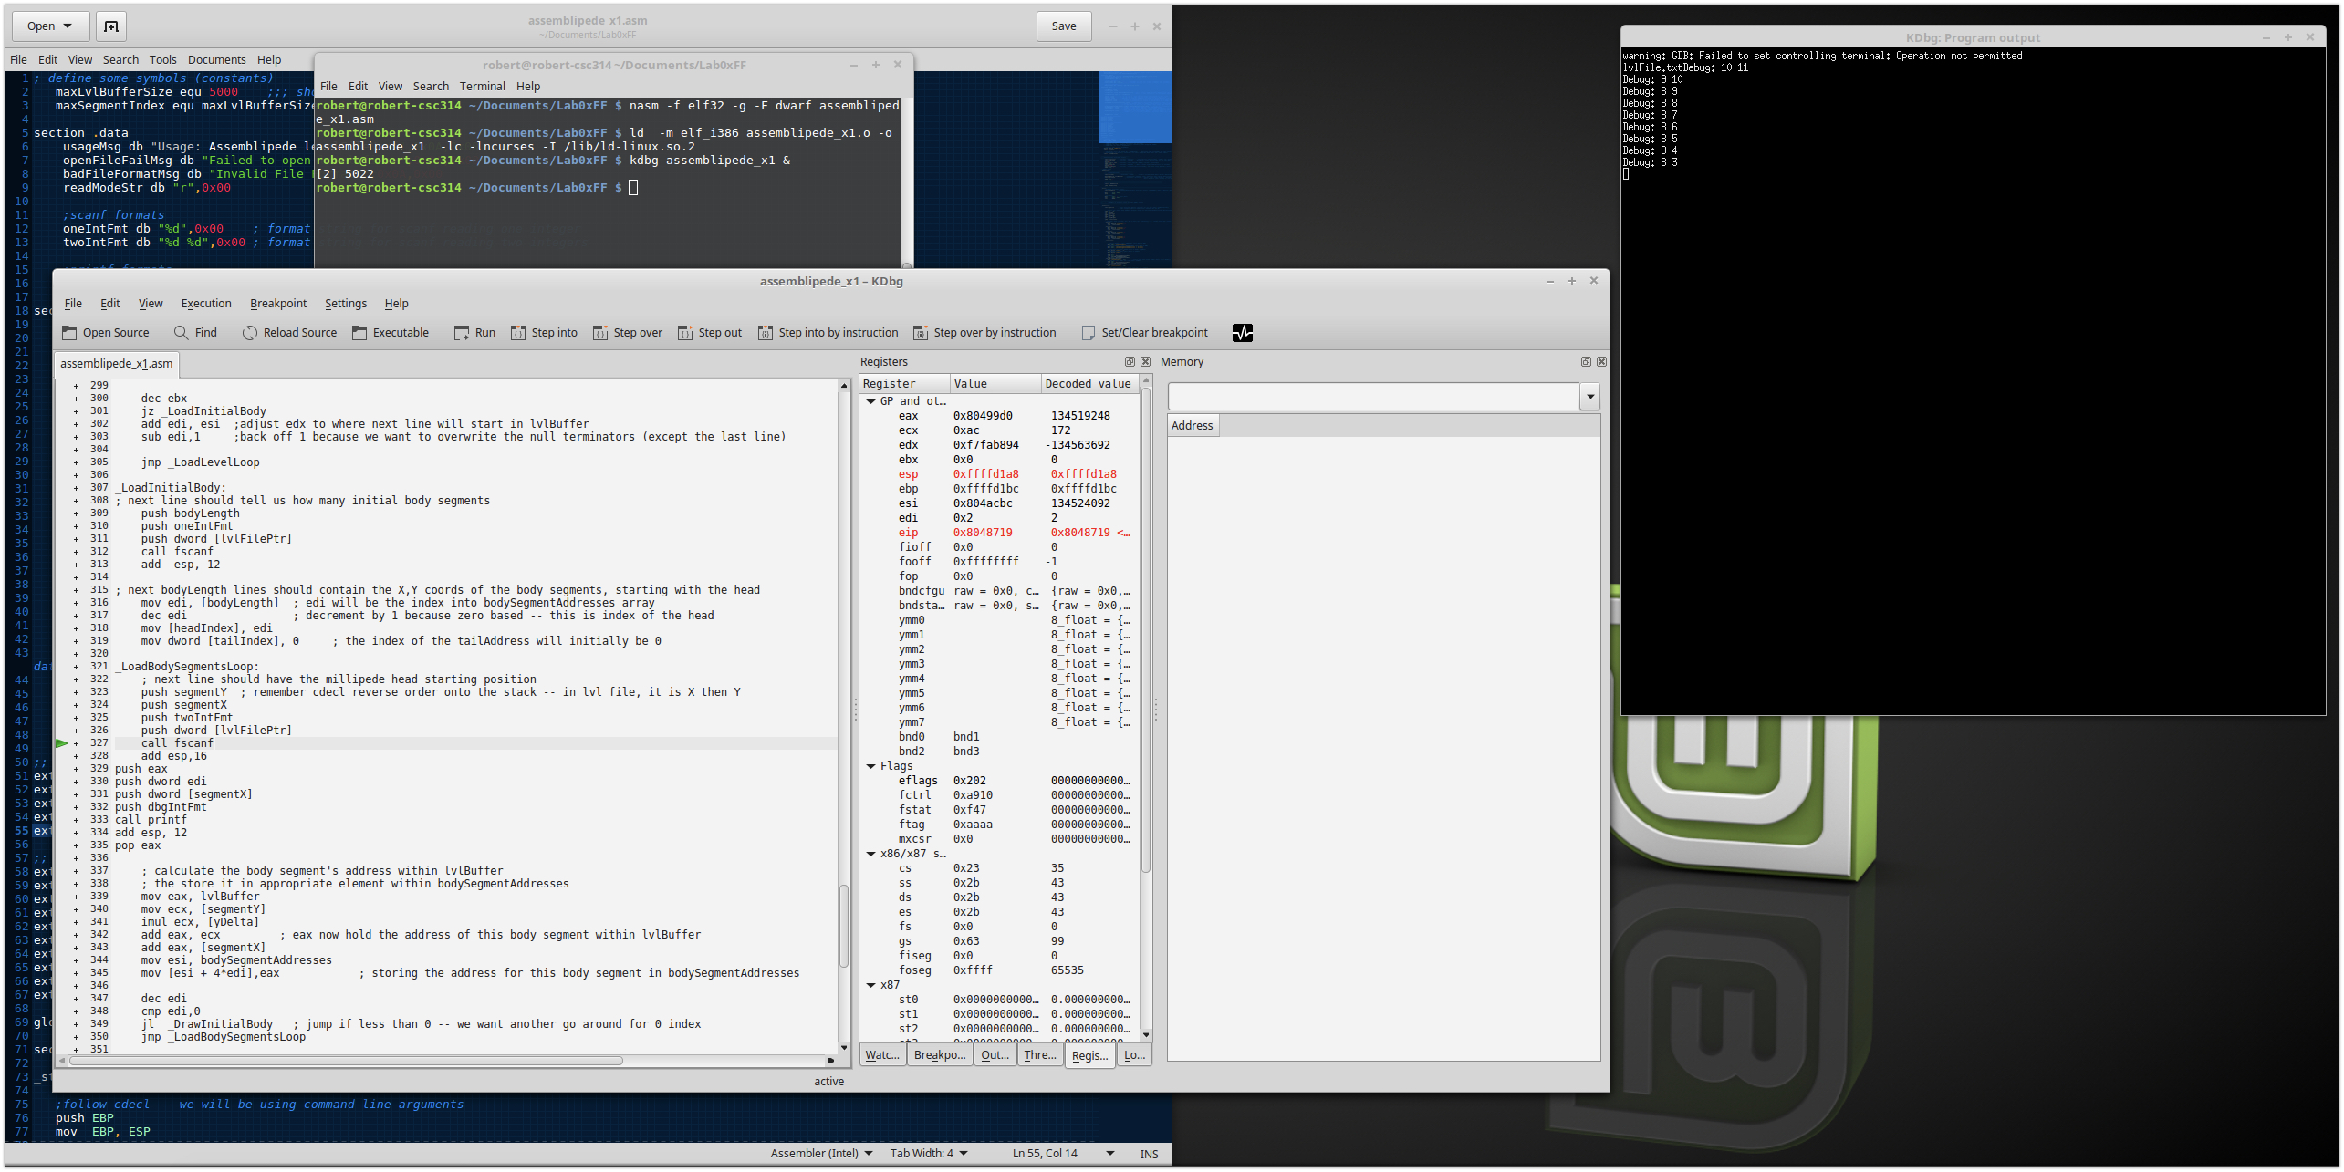

Running my first version of the program. Trying to figure out how to stop it from shrinking.

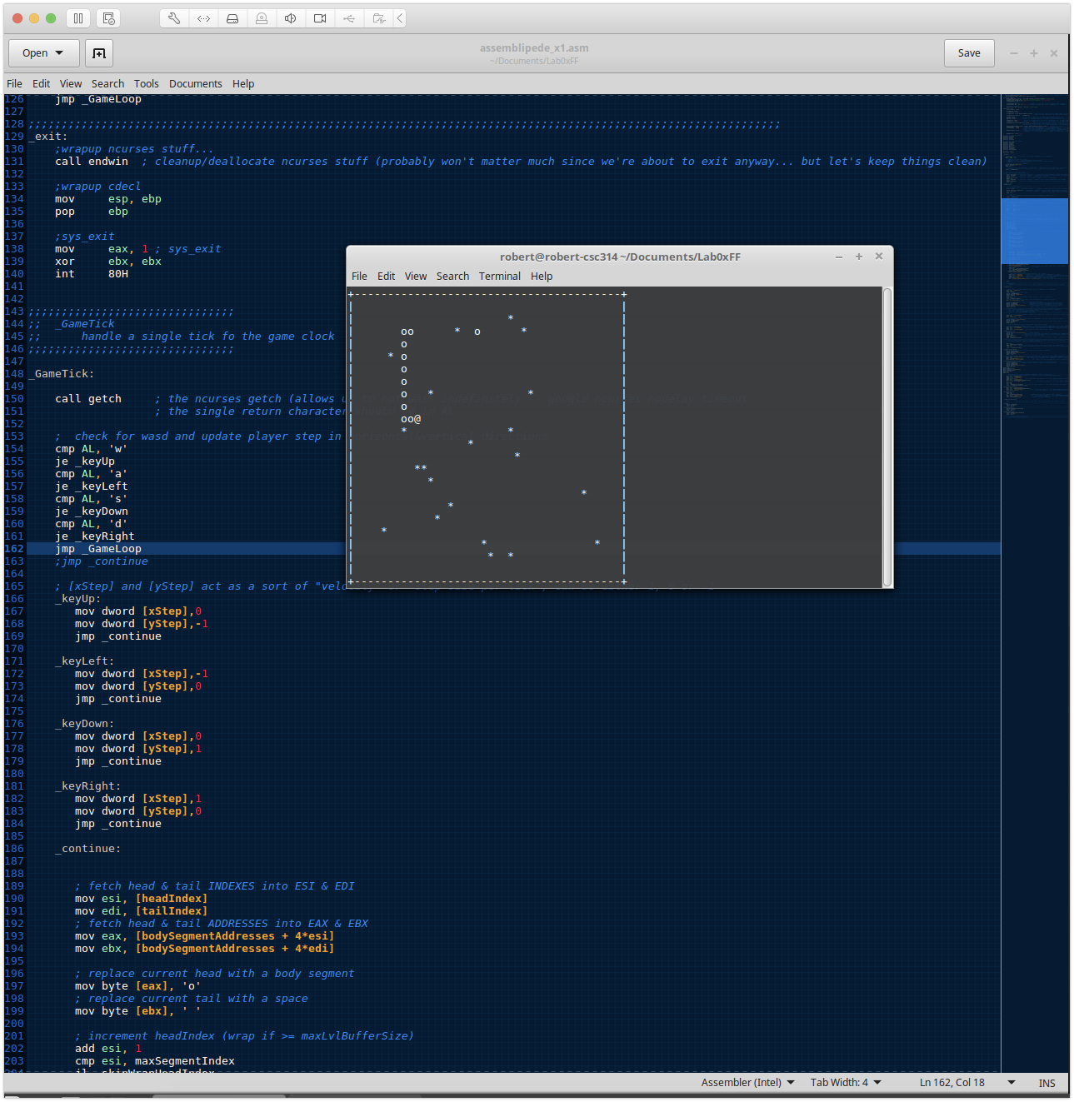

Trying to test and figure out how to stop the assemblipede from shrinking.

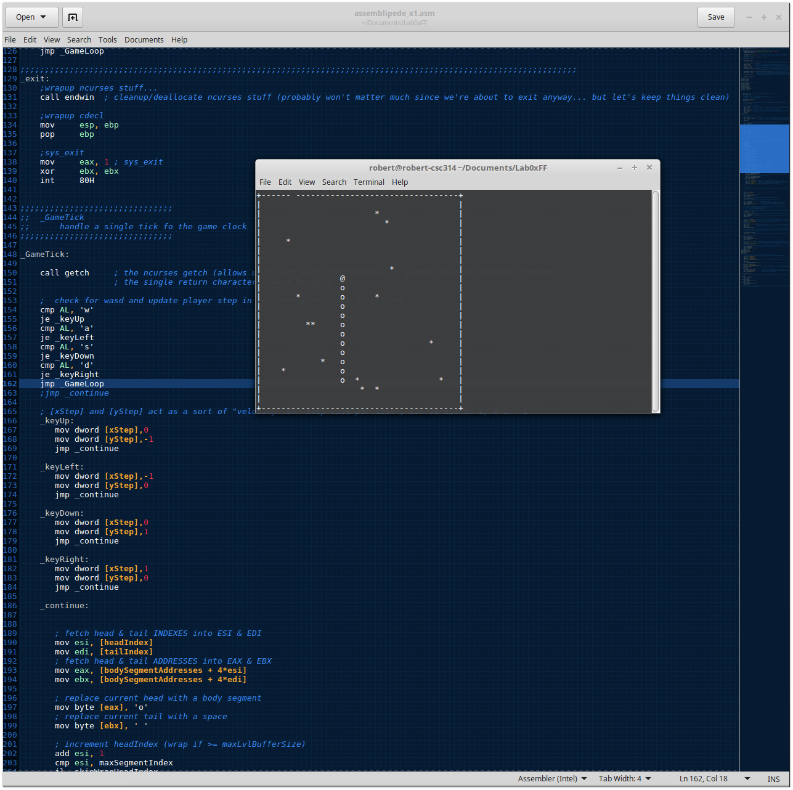

Using kdbg to figure out how I can stop the assemblipede from shrinking.

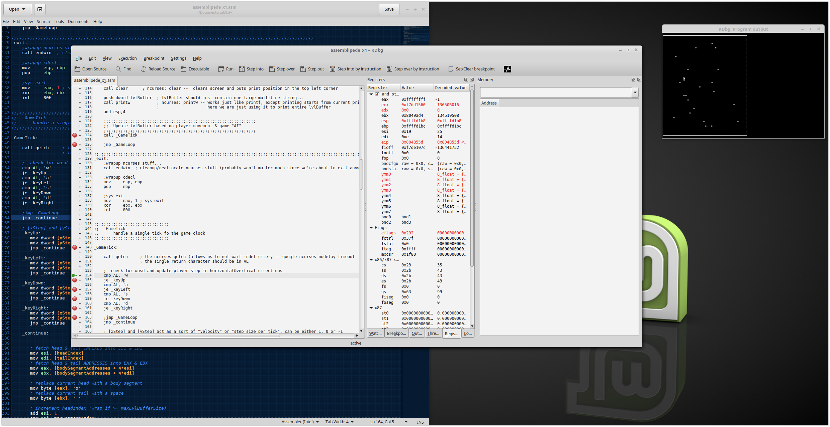

I’ve figured out a way to stop it from shrinking and I’m testing that out now.

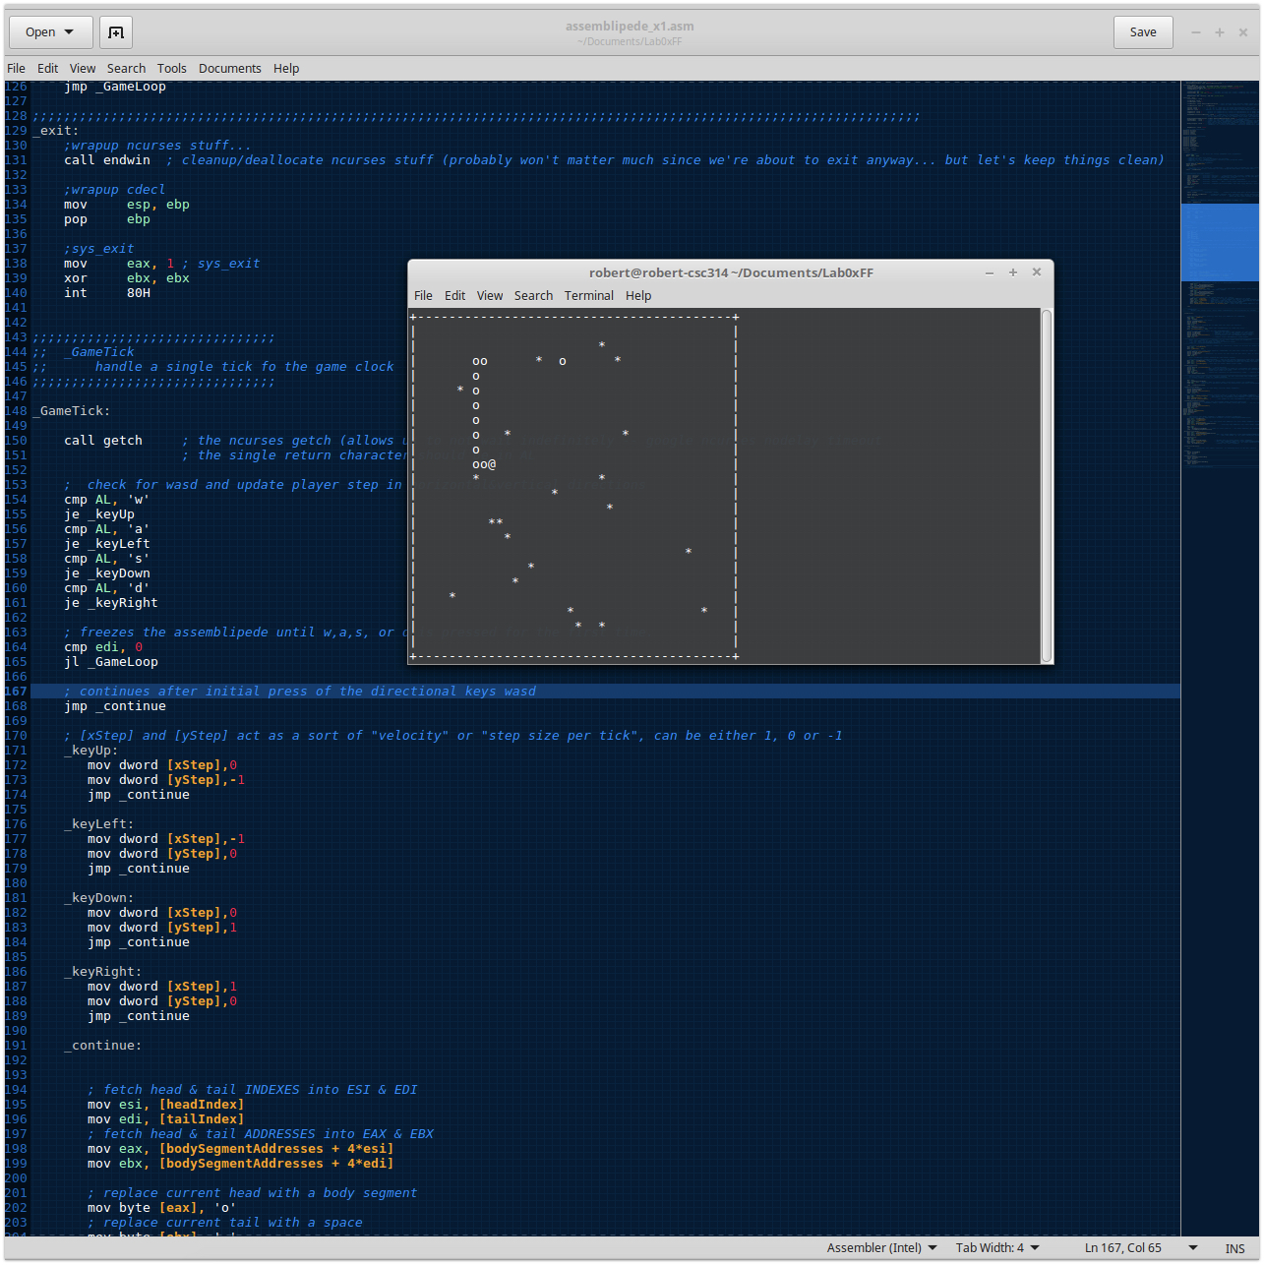

Adding the pause feature and testing it out.

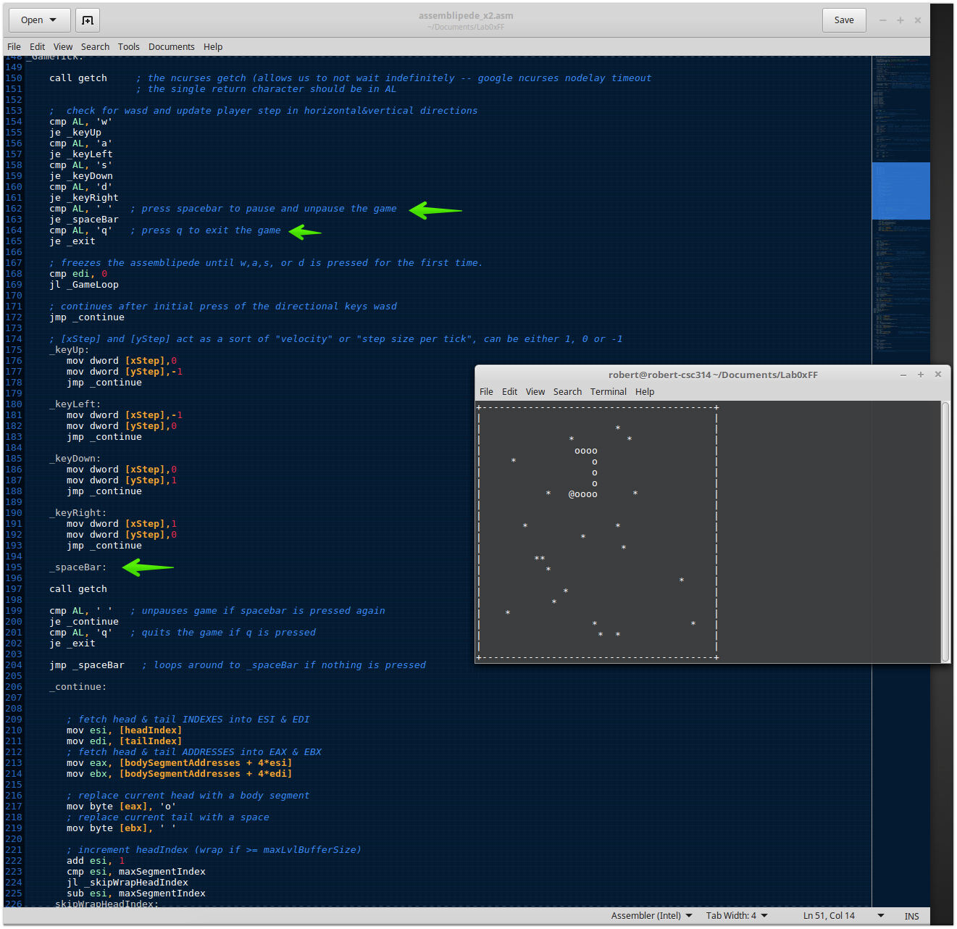

Wanted to print pause on the screen so I’m researching how to use mvprintw

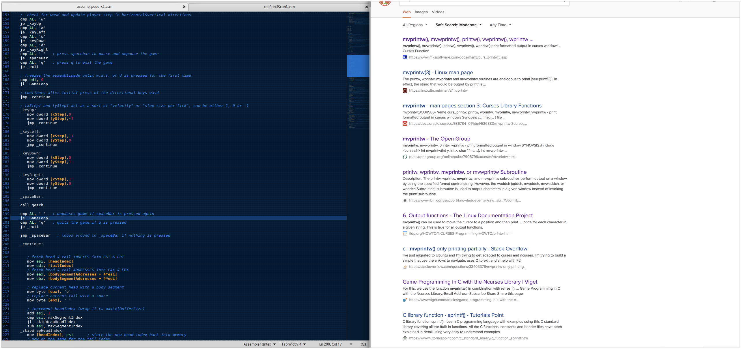

Trying to use mvprintw, but I’m unsuccessful at printing a pause screen.

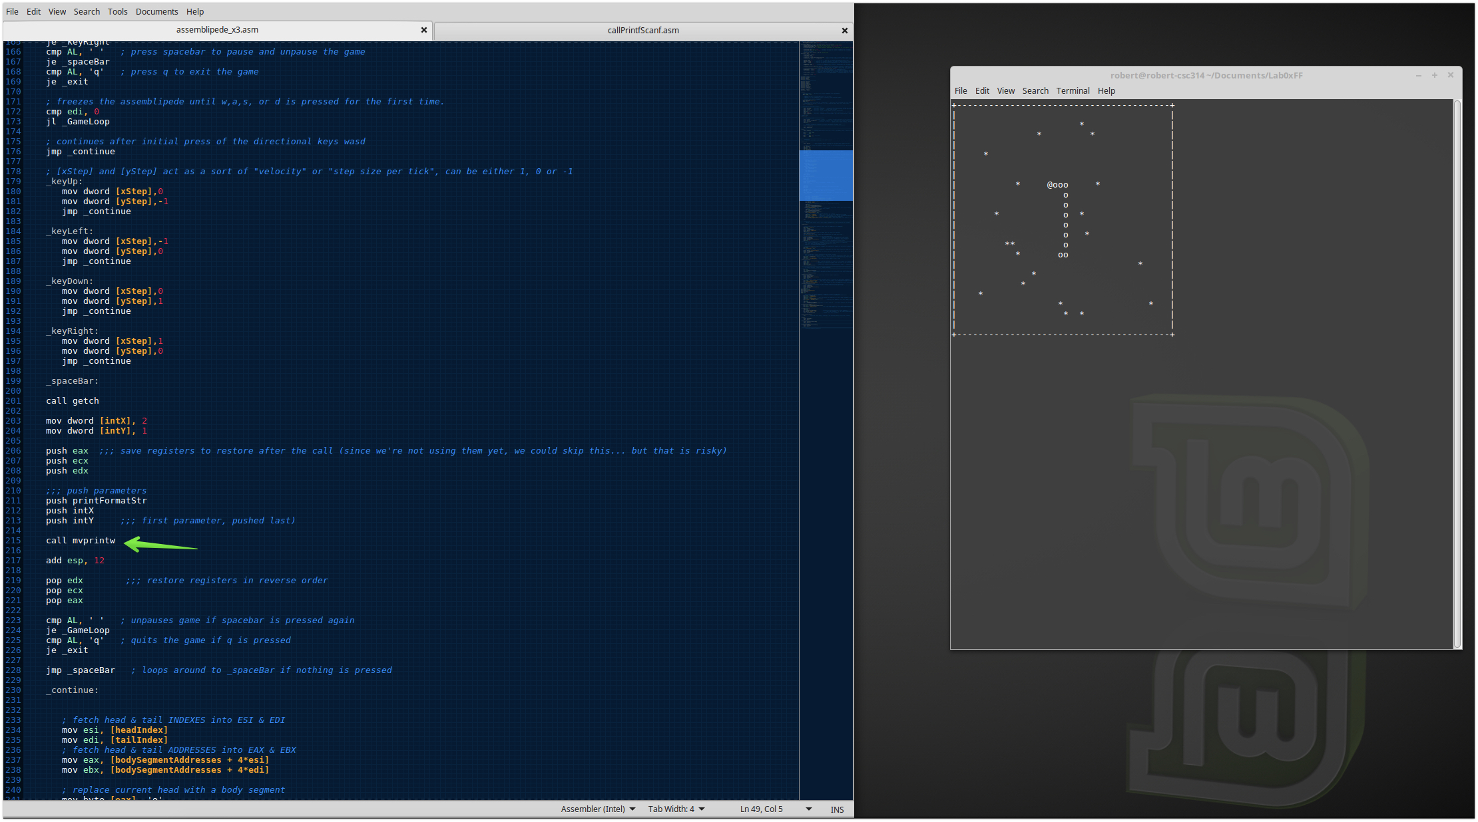

I was able to print a pause screen with printw, but it isn’t where I wanted it and it was repeating as well while I was testing it in the loop, so I moved it out of the original loop and created another loop with just the call getch.

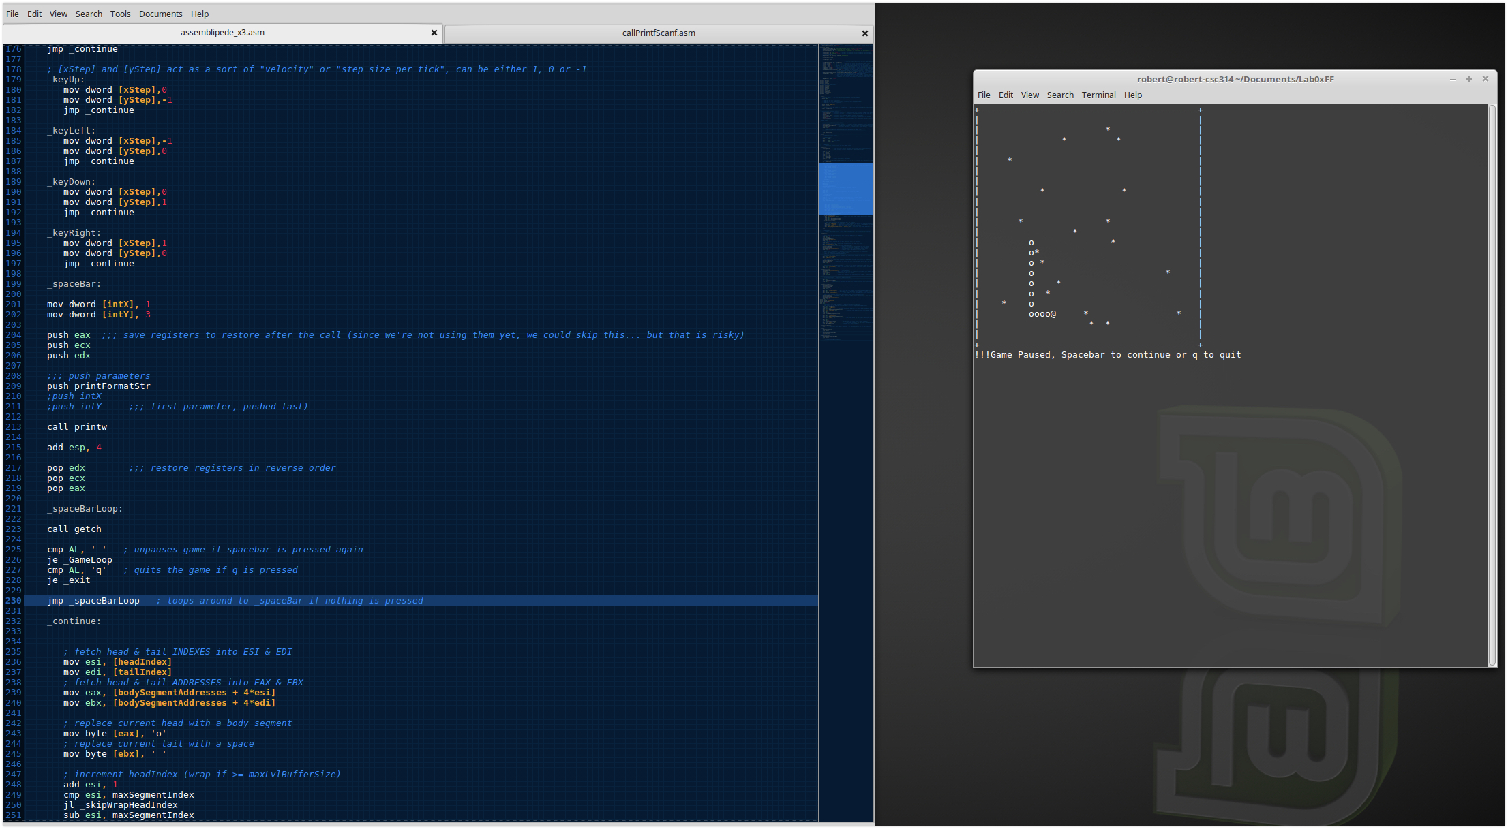

Learned about using move to move the cursor so I could call printw at a different place on the screen. Took advantage of that and created a nice pause menu.

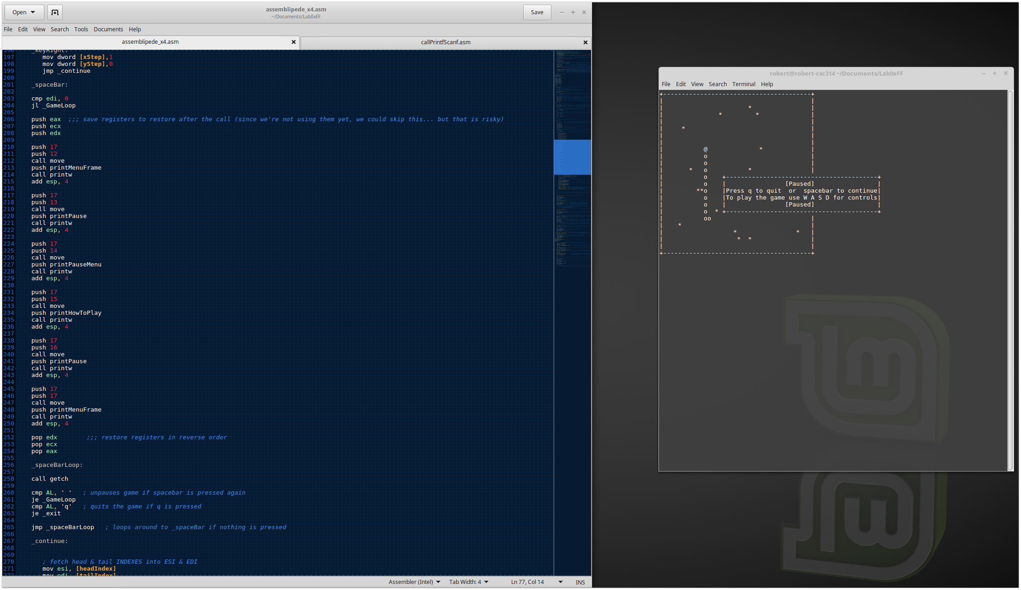

While using the pause menu I’m testing how to stop the game when it hits ‘|’. Probably should have also taken a picture of me testing it in kdbg from earlier while watching the video of how the assembled moves. I realized that I could add some code right where the movement is, but it didn’t work.

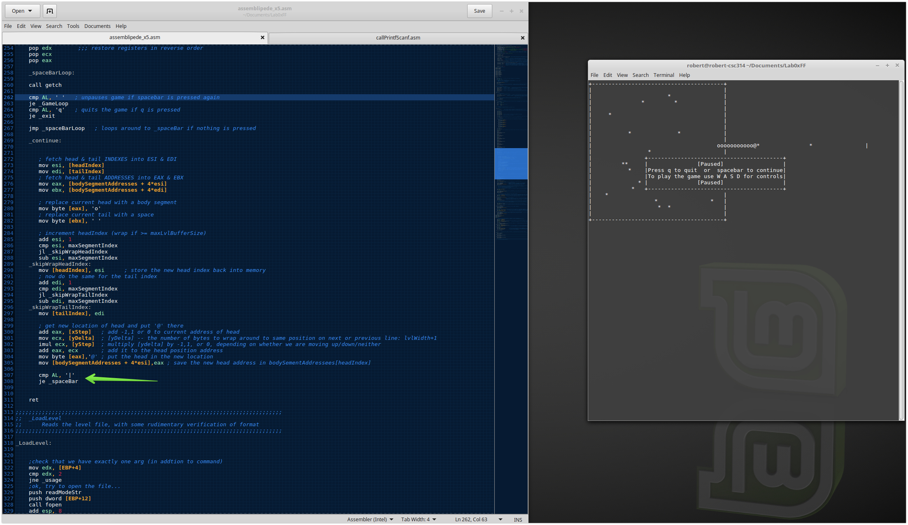

Trying to test getting the assemblipede to stop on the wall, but ran into a build error.

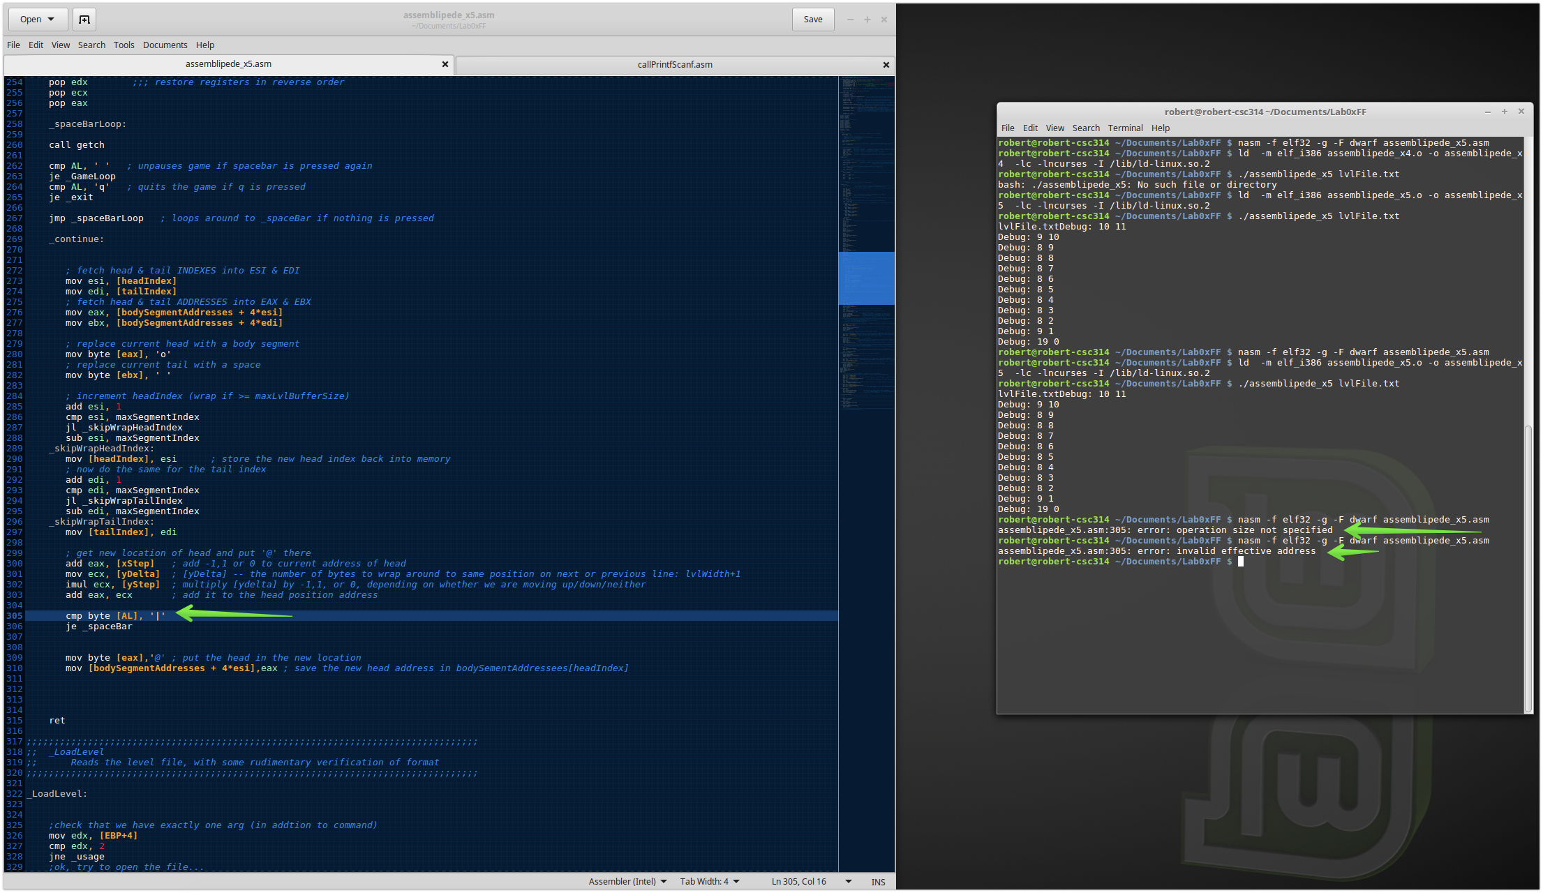

I figured out how to build it and it works with my pause screen. After this I added the other characters +, -, and o and begun testing with a game over menu.

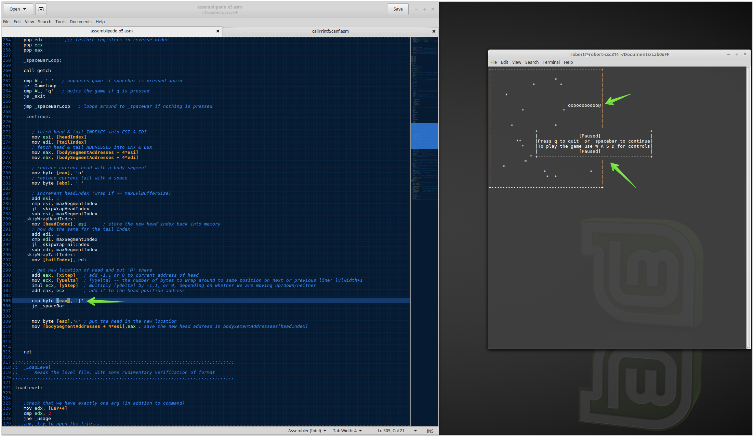

Trying to get the game over loop working. Got an error due to a typo.

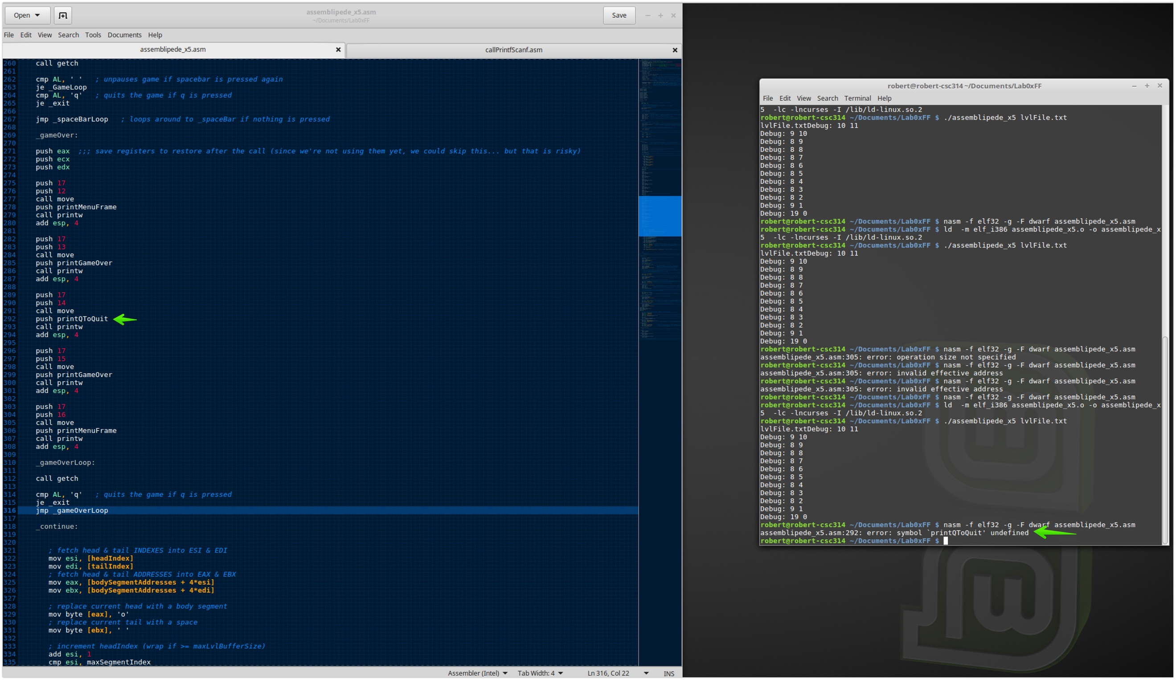

At this point I’ve polished up the pause and game over menus and I’m testing them out.

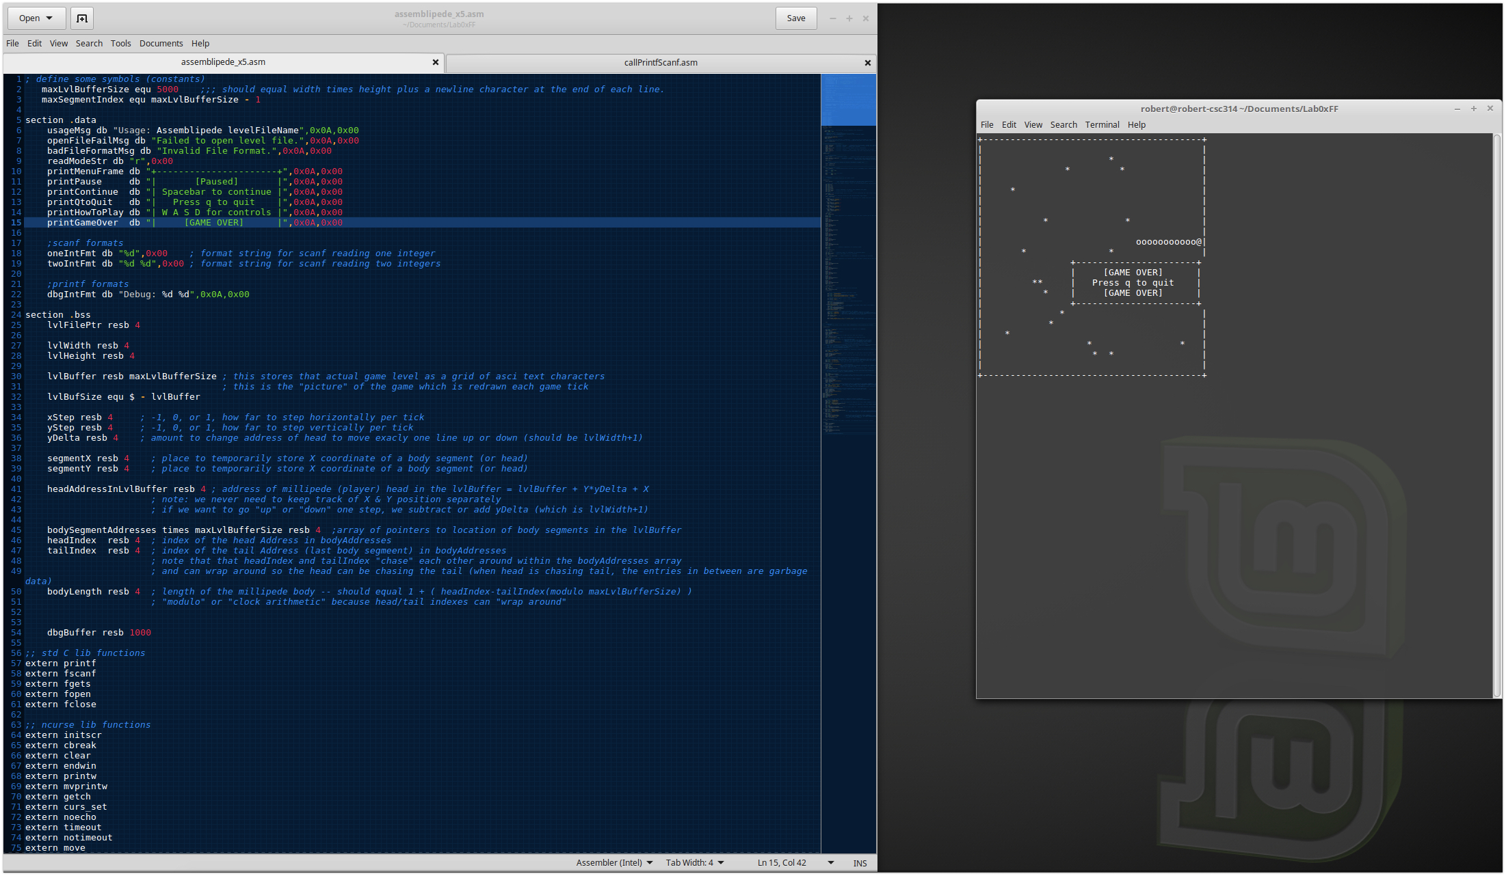

This is showing where I’m testing out the other characters. I’m showing here that it will game over if it runs into itself.

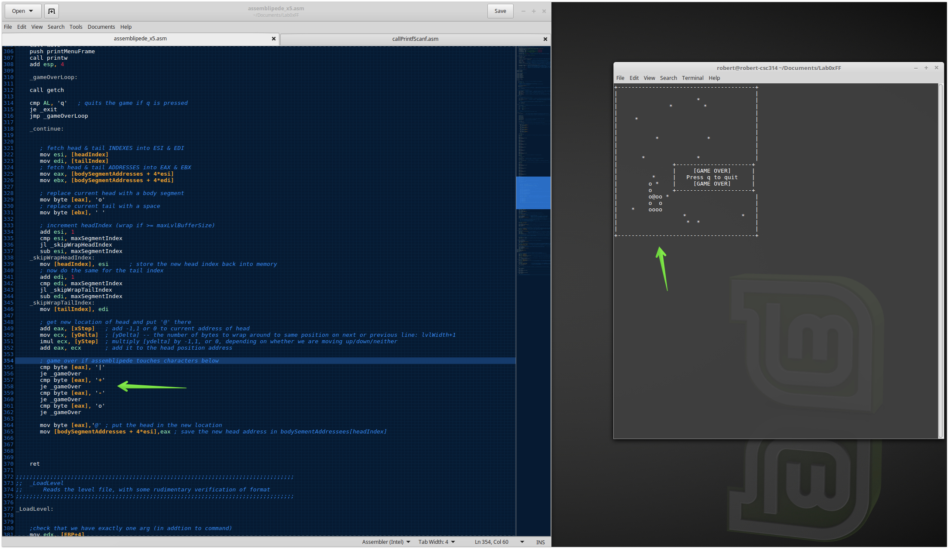

This is where I got frustrated, because I pressed ‘a’ and it said game over. At the time I thought it was the character I was pressing.

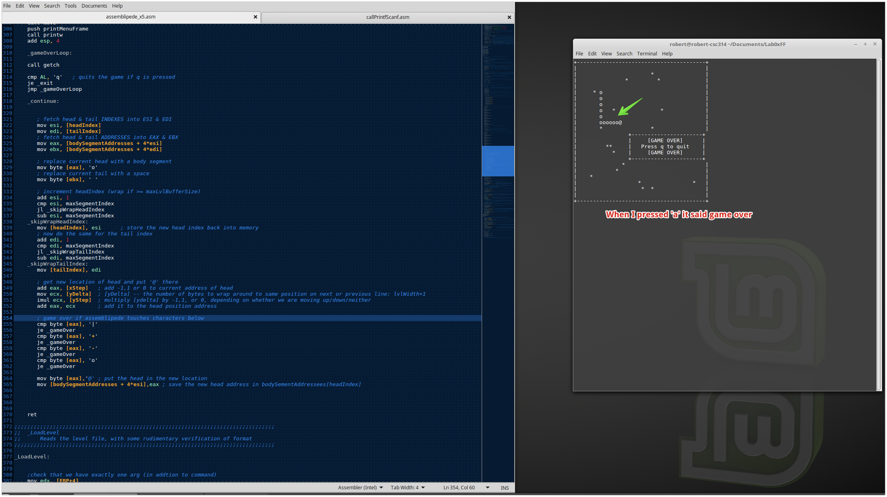

More testing of why when I press ‘a’ and ‘w’ it was saying game over. I changed from using ‘+’, etc to using the hexadecimal numbers from the ascii code trying to troubleshoot what was going wrong. I realized that it was doing what it was supposed to be doing. When I pressed ‘w’ it was going up toward itself as well as previously when I pressed ‘a’ it was going back on itself and is the reason why it said gameover.

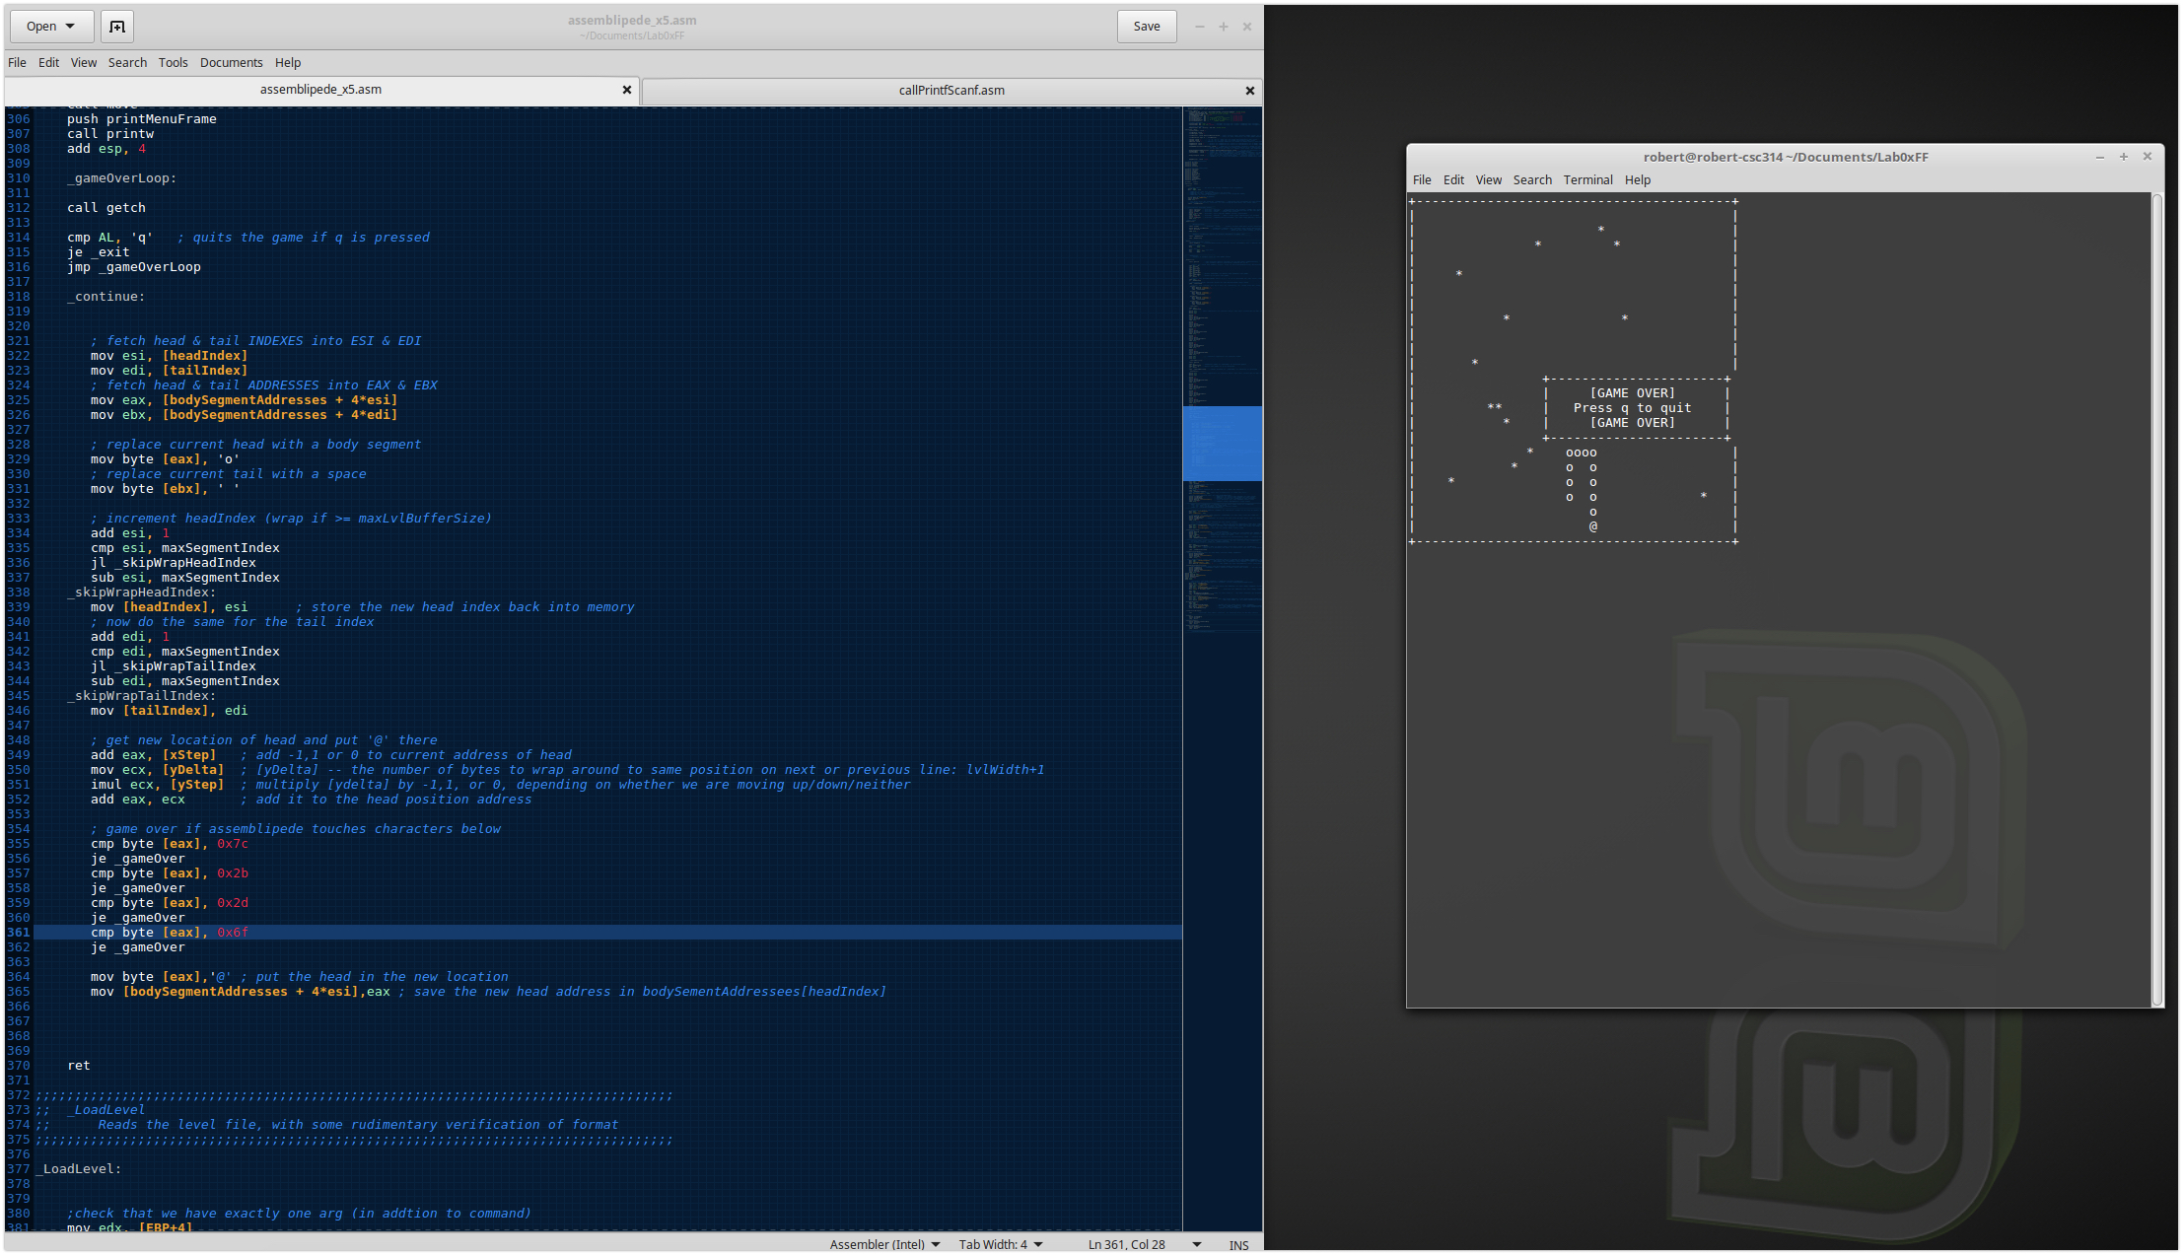

I started to work on the tail to get it to grow and was unsuccessful. I copied the code block right blow where I have _growTail. I figured I could use that code, but not use where it says to replace with a space. This didn’t work. I got really frustrated and was running out of time.

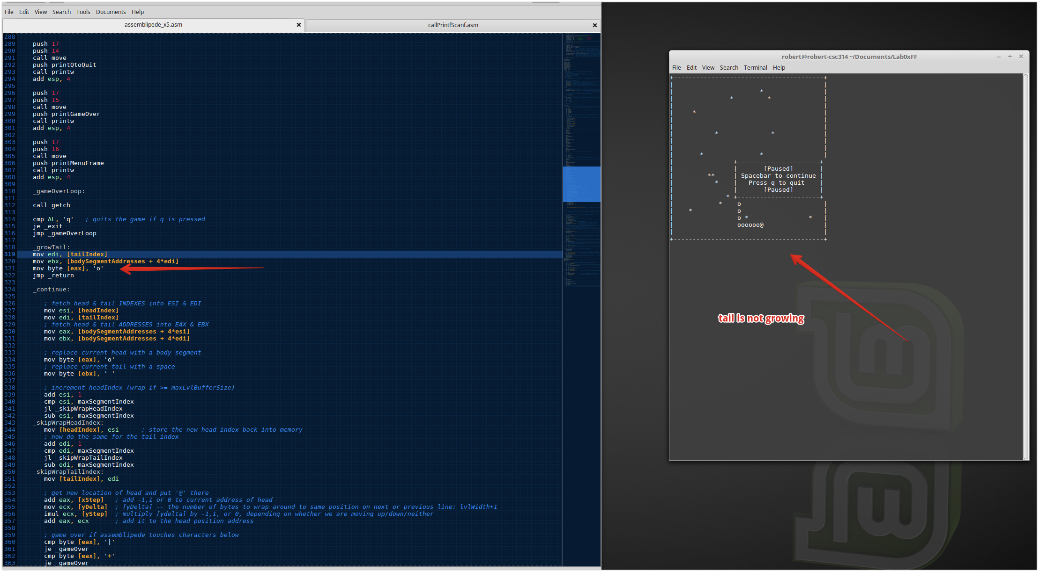

This last screen was just a shot of all the versions of the code I was working with. I tried a few different things as well as attempted to use some form of version control so when I made a change if it didn’t work I could go back and try something different. My goal is to eventually learn how to use git so I can automate this process some.

